AM000-Asia-China-Tang- Seven Lions and Grapes-618-907 CE

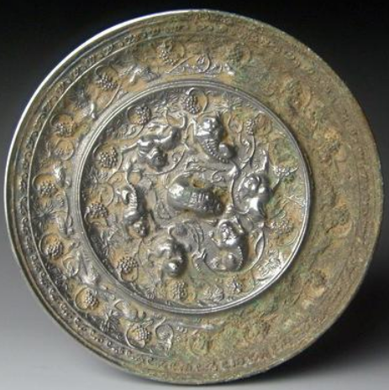

# Seven Lions and Grapes Mirror, Tang Dynasty (618–906CE) 5.1 in., 415 gm.

The introduction of the Lion and Grapes Mirror from Xinjiang in western China during the latter Sui dynasty only accounted for five lions, four of which spiraled around a central fifth. During the course of popularity of the exotic nature of the lion and the grape in areas in which it was never indigenous the embellishment of these mirrors took on different aspects. In this example two additional lions have been added to emphasize its exotic creatures, and the tendrils of grape clusters are also exaggerated. The lions assume poses that are paired, while their eyes appear looking up at the viewer. In the outer band with the grapes are birds with extended wings. The dating of this development of the Lion and Grapes mirror with extra-numerary lions can be ascertained from an excavated example from the famed tomb of Dugu Shizhen near Xi'an date ca. 698, in which the extra lions and the added grapevines produce an impact similar to this in order to excite the sense of the exotic (Wang Zhongshu 1982: 29).

References:

Chou, Ju-hsi. 2000. *Circles of Reflection: The Carter collection of Chinese bronze mirrors.* Cleveland: The Cleveland Museum of Art.

Wang Zhongshu 1982. The date of the takamasuka tomb and the identitiy of the deceased, *Kaog*u 4: 410-413.



 